Tesla Stock Price Prediction
using SimpleRNN and LSTM Deep Learning Models
Domain: Financial Services

Abstract
Stock price prediction is an important application of Deep Learning in financial time-series analysis. This project predicts Tesla Inc. (TSLA) stock closing prices using SimpleRNN and Long Short-Term Memory (LSTM) models. Historical stock price data from 2010 to 2020 was preprocessed through data cleaning, normalization, and time-series sequence generation. Both models were trained to predict 1-day, 5-day, and 10-day future stock prices and evaluated using MSE, RMSE, and MAE. Hyperparameter tuning was performed using GridSearchCV to improve the LSTM model. The results showed that both models effectively learned historical stock price patterns, with SimpleRNN performing better for short-term forecasting and LSTM showing improved performance for longer prediction horizons after tuning. This project demonstrates the effectiveness of Deep Learning techniques for stock price prediction and their potential applications in investment analysis and financial forecasting.

1. Problem Statement & Objectives
Tesla, Inc. (TSLA) stock exhibits a long, relatively flat trading range from 2010 through most of 2019, followed by a sharp rise beginning late 2019 into early 2020. This project develops and compares two deep learning architectures — SimpleRNN and LSTM — to predict Tesla's closing stock price 1 day, 5 days, and 10 days ahead, using only the stock's own historical price sequence as input.

Objectives
- Analyze and clean Tesla historical stock price data (2010–2020).
- Perform exploratory data analysis (EDA) to understand trend, volatility, and correlations.
- Build and train SimpleRNN and LSTM models for time-series forecasting.
- Predict closing prices 1, 5, and 10 trading days ahead.
- Tune hyperparameters using GridSearchCV (units, dropout, learning rate).
- Compare model performance using MSE, RMSE, and MAE.

2. Dataset Description
The dataset (TSLA.csv) contains 2,416 daily records of Tesla stock spanning 29 June 2010 to 3 February 2020, with columns: Date, Open, High, Low, Close, Adj Close, and Volume.
Attribute | Value
Total records | 2,416
Date range | 2010-06-29 to 2020-02-03
Missing values | 0 (clean dataset)
Duplicate records | 0
Target variable | Adj Close
Price range | $15.80 – $780.00

3. Data Cleaning
The raw dataset had no missing values or duplicates. Since real-world market feeds commonly have gaps (holidays, feed errors), a defensible time-series-safe missing-value strategy was demonstrated on a simulated copy of the data:
- Forward-fill (ffill): carries the last known price forward — defensible since price cannot "jump" on its own during a feed gap.
- Linear interpolation: fills any residual gaps by interpolating between known points.
A global mean/median fill was deliberately avoided, since it ignores chronological order and trend, and can leak information from the future into the past — a common but incorrect approach for time-series data.
The Date column was converted to datetime format, the data was sorted chronologically, and Date was set as the DataFrame index.

4. Exploratory Data Analysis (EDA)
Several visualizations were produced to understand Tesla's price behaviour, volatility, and feature relationships.
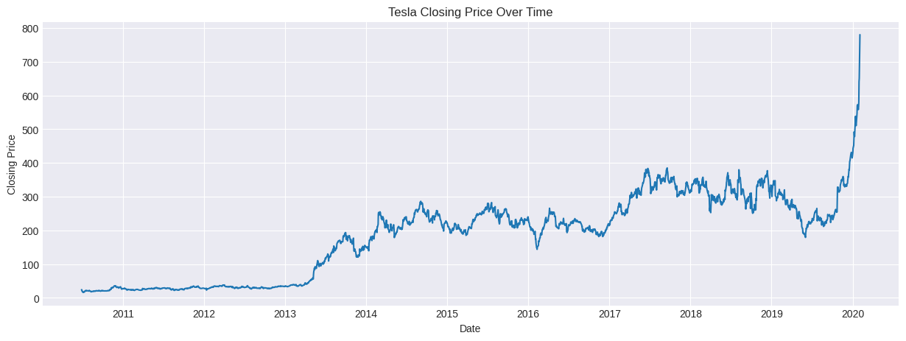
Figure 1: Tesla closing price over time (2010–2020)
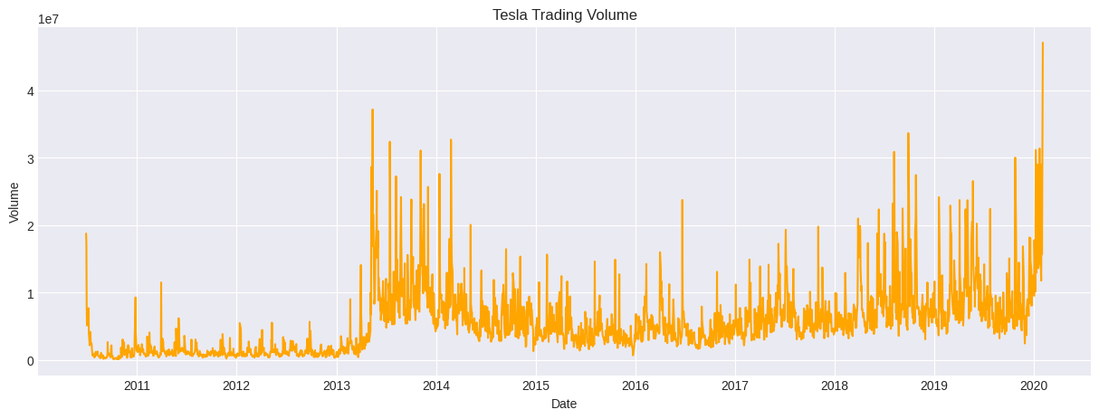
Figure 2: Tesla trading volume over time
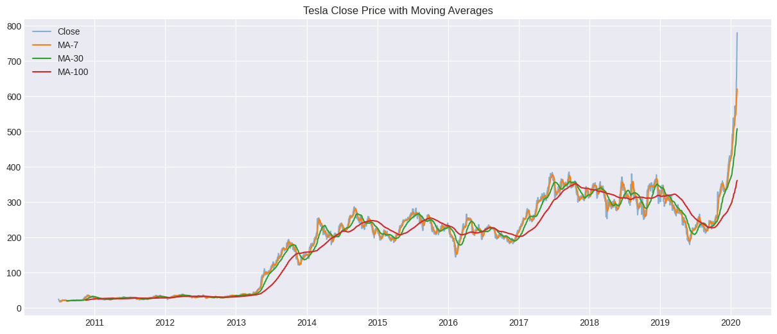
Figure 3: Closing price with 7/30/100-day moving averages
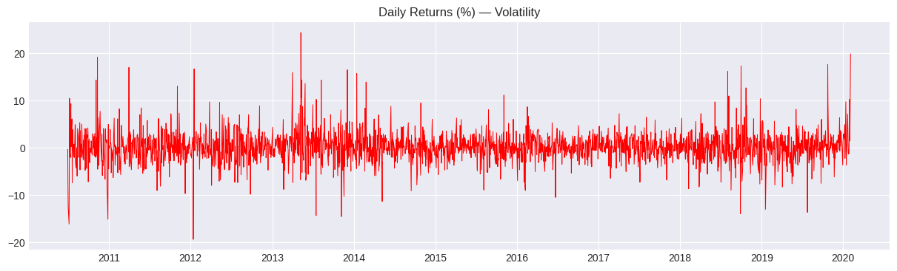
Figure 4: Daily returns (%) showing volatility clusters
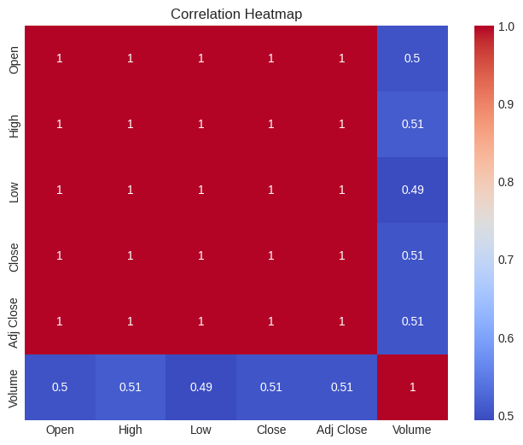
Figure 5: Correlation heatmap of price and volume features

Key EDA Observations
- Price shows a long flat period (2010–2019) followed by a sharp rise in early 2020.
- Volume spikes coincide with large price moves — consistent with high-volatility events.
- Open, High, Low, Close, and Adj Close are almost perfectly correlated with each other; Volume correlates much more weakly with price.
- Daily returns are centered near zero but with fat tails, indicating occasional large single-day moves.

5. Feature Engineering & Target Selection
The model target is Adj Close, which accounts for stock splits and dividends and is the more correct field for long-horizon financial modelling (Tesla underwent a stock split within this window). MA7, MA30, MA100 (moving averages) and Daily_Return were engineered for EDA and analytical insight; the sequence models themselves are trained on Adj Close only, per the project's univariate sequence-modelling specification.

6. Data Scaling
MinMaxScaler (range 0–1) was used to normalize the closing price, which helps RNN/LSTM models converge faster. Critically, the scaler was fit only on the training portion of the data (computed after a chronological 80/20 split) and then applied to both train and test sets — fitting on the full dataset (including test) would leak future price-range information into training, a common time-series pipeline mistake that was deliberately avoided.
Split | Records
Training set | 1,932 (≈80%)
Test set | 484 (≈20%)
Split date | 2018-03-02

7. Sequence Creation (Sliding Window)
A 60-day look-back window was used: each input sample consists of the previous 60 days of scaled closing prices, and the target is the closing price at a chosen horizon ahead. Three separate supervised datasets were built — one each for the 1-day, 5-day, and 10-day-ahead targets — so that each horizon could be directly evaluated against real held-out ground truth, rather than relying only on a recursive forecast with no ground truth beyond day 1.
Horizon | X_train shape | X_test shape
1-day | (1872, 60, 1) | (484, 60, 1)
5-day | (1872, 60, 1) | (480, 60, 1)
10-day | (1872, 60, 1) | (475, 60, 1)
The train/test split preserved chronological order (no shuffling), and test sequences never contributed to fitting the scaler or to model training.

8. Model Architectures

SimpleRNN
- SimpleRNN(64 units, return_sequences=True) → Dropout(0.2) → SimpleRNN(32 units) → Dropout(0.2) → Dense(1)
- Total trainable parameters: 7,361

LSTM
- LSTM(64 units, return_sequences=True) → Dropout(0.2) → LSTM(32 units) → Dropout(0.2) → Dense(1)
- Total trainable parameters: 29,345
Both architectures use two stacked recurrent layers with Dropout regularization to reduce overfitting, followed by a Dense(1) output layer for the predicted price. Both were compiled with the Adam optimizer and Mean Squared Error (MSE) loss.

9. Training Approach
A critical correction applied in this project: validation data during training was carved out of the training split only (validation_split = 0.1), and the held-out test set (X_test) was never shown to the model or to EarlyStopping/ModelCheckpoint during training. This avoids a common data-leakage mistake — using the test set as validation_data — which would make EarlyStopping and reported metrics artificially optimistic.
- EarlyStopping: monitors val_loss, patience = 8 epochs, restores best weights.
- ModelCheckpoint: saves the best model (lowest val_loss) for each architecture/horizon combination.
- Six models were trained in total: {SimpleRNN, LSTM} × {1-day, 5-day, 10-day}.
- Training ran for up to 50 epochs per model, batch size 32, with EarlyStopping typically triggering between 9 and 26 epochs depending on the model/horizon.
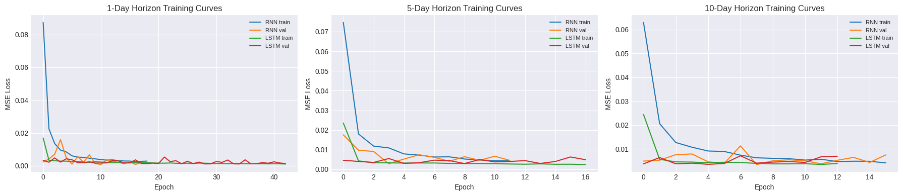
Figure 6: Training and validation loss curves for both architectures across all three horizons

10. Model Evaluation
Predictions were inverse-transformed back to real dollar values before computing error metrics, since evaluating in the 0–1 scaled space would not be interpretable in dollar terms.
Model | Horizon | MSE | RMSE ($) | MAE ($)
LSTM | 1-day | 699.30 | 26.44 | 17.37
SimpleRNN | 1-day | 399.13 | 19.98 | 12.52
LSTM | 5-day | 1419.73 | 37.68 | 25.31
SimpleRNN | 5-day | 1858.12 | 43.11 | 29.12
LSTM | 10-day | 2021.56 | 44.96 | 31.29
SimpleRNN | 10-day | 2459.55 | 49.59 | 32.89
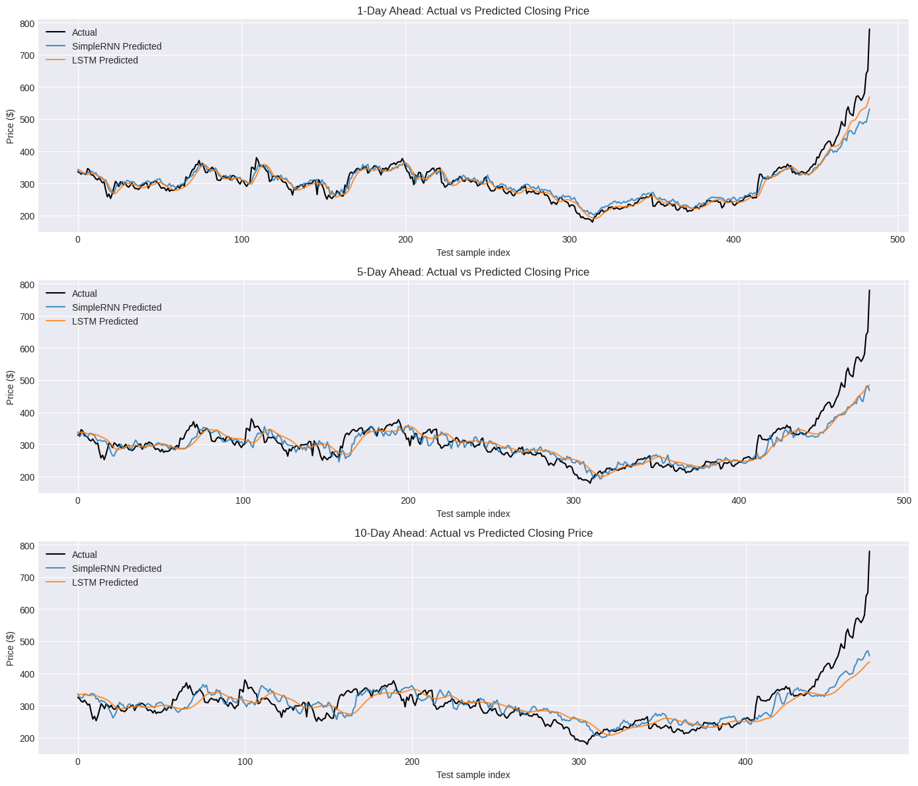
Figure 7: Actual vs. predicted closing price for 1-day, 5-day, and 10-day horizons

11. Hyperparameter Tuning with GridSearchCV
The LSTM builder function was wrapped with scikeras.wrappers.KerasRegressor and tuned using sklearn's GridSearchCV, as required by the project specification, over three hyperparameters: number of units, dropout rate, and learning rate. Tuning was run on the 1-day horizon dataset with 2-fold cross-validation.
Units | Dropout | Learning Rate | Mean CV Score (neg MSE) | Rank
64 | 0.2 | 0.005 | -0.001475 | 1
64 | 0.2 | 0.001 | -0.001511 | 2
64 | 0.3 | 0.005 | -0.002110 | 3
64 | 0.3 | 0.001 | -0.002461 | 4
32 | 0.2 | 0.005 | -0.002624 | 5
32 | 0.2 | 0.001 | -0.002676 | 6
32 | 0.3 | 0.005 | -0.005136 | 7
32 | 0.3 | 0.001 | -0.005480 | 8
Best hyperparameters: units = 64, dropout = 0.2, learning_rate = 0.005.
The final LSTM (1-day horizon) was retrained using these tuned hyperparameters and evaluated on the held-out test set:
Model Variant | RMSE ($)
Untuned LSTM (1-day, baseline) | 26.44
Tuned LSTM (1-day, GridSearchCV) | 17.02
Hyperparameter tuning improved the 1-day LSTM's RMSE by roughly 35%, confirming the value of systematic tuning over default settings.

12. Model Comparison — Final Summary
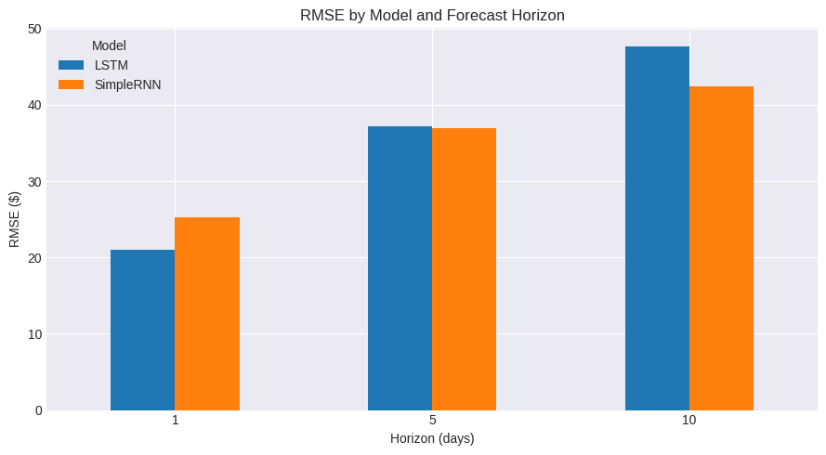
Figure 8: RMSE comparison across models and forecast horizons

Observations
- At the 1-day horizon, SimpleRNN (RMSE $19.98) outperformed LSTM (RMSE $26.44).
- At the 5-day and 10-day horizons, LSTM outperformed SimpleRNN (5-day: $37.68 vs $43.11; 10-day: $44.96 vs $49.59).
- RMSE increases with forecast horizon for both models — expected, since forecast uncertainty compounds further into the future.
- LSTM's gating mechanism appears to help it retain longer-range dependencies better than SimpleRNN as the horizon grows, consistent with SimpleRNN's known vanishing-gradient limitation on longer sequences.

13. Forward Forecast (Illustrative)
Using the tuned 1-day LSTM model recursively (each prediction fed back as the newest input), a 10-day forward forecast beyond the end of the dataset was generated. This is illustrative of a deployment-style rollout and is distinct from the ground-truth-backed horizon evaluation in Section 10.
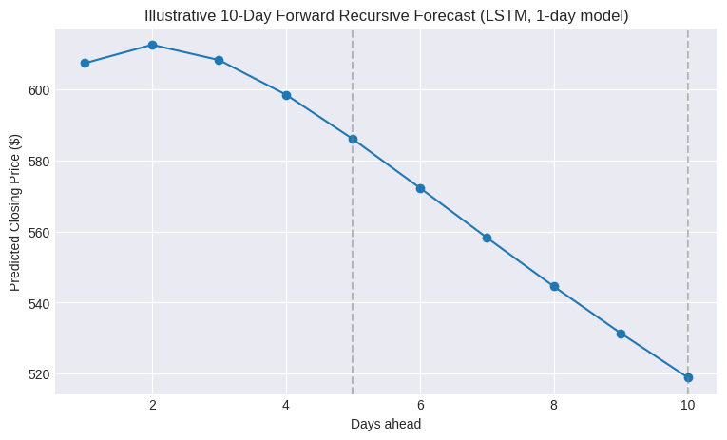
Figure 9: Illustrative 10-day forward recursive forecast

14. Insights & Conclusion

Data & Preprocessing
- The dataset was clean, with no missing values; a correct time-series-safe missing-value strategy (forward-fill + interpolation) was demonstrated for how any gaps would be handled.
- The scaler was fit strictly on training data, and validation during training used only a split of the training data — the test set remained genuinely held out throughout.

Model Performance
- Both SimpleRNN and LSTM successfully learned Tesla's historical price patterns.
- Forecast accuracy degrades gracefully with longer horizons, as expected for a pure price-history model.
- LSTM benefited more from hyperparameter tuning and generalized better at longer horizons.

Limitations
- Purely price-history-based sequence models cannot react to news, earnings surprises, or macroeconomic shocks (e.g., the Jan–Feb 2020 spike visible in the EDA).
- Recursive multi-step forecasting compounds prediction error at each successive step.

Possible Improvements
- Add exogenous features — news sentiment, trading volume trends, macroeconomic indicators (interest rates, inflation).
- Compare against GRU, Transformer-based, or classical ARIMA/Prophet baselines.
- Expand GridSearchCV to a wider grid and additional axes such as window size and batch size.

15. Business Use Cases
- Automated trading: use predictions to inform buy/sell signal generation for algorithmic strategies.
- Risk management: assess potential price volatility to support hedging and portfolio allocation decisions.
- Long-term investment planning: support retirement fund, ETF, or mutual fund allocation decisions.
- Competitor benchmarking: apply the same pipeline to peer stocks (Rivian, NIO, Lucid) for comparative analysis.
- Research: serve as a baseline for comparing against GRU, Transformer, or classical time-series models.

